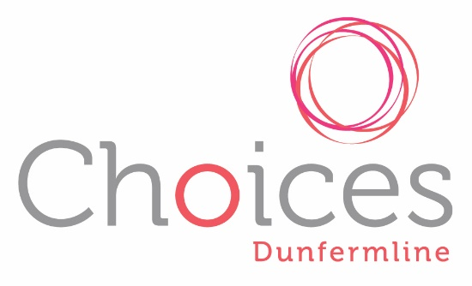

Choices Dunfermline
Privacy Policy
Introduction
In accordance with the General Data Protection Regulation (GDPR), Choices Dunfermline aims to process all personal data fairly and in a transparent manner.
The following lawful basis for processing as set out in Article 6 of the GDPR, applies whenever Choices Dunfermline processes personal data:
(a) Consent: the individual has given clear consent for you to process their personal data for a specific purpose.
(d) Vital interests: the processing is necessary to protect someone’s life.
For the purposes of the Data Protection Act 1998 the privacy and security of our service users is important to us. This privacy policy explains how we use the information we collect about you, how you can instruct us if you prefer to limit the use of that information, and the procedures that we have in place to safeguard your privacy.
Our privacy policy relates only to information that we obtain from you or a referring agency. If you visit a website operated by a third party through a link included on the websites, your information might be used differently by the operator of the linked website.
THE INFORMATION WE COLLECT AND KEEP
The type of information we may collect about you includes:
- your name and address
- Your phone number and/ or e-mail address
- Details about the services you specifically request
- Your gender and age
- Brief notes following each session

HOW WE USE THE INFORMATION
We will not collect or store any other sensitive information about you without your explicit consent.
The information you provide to us will be processed for the following reasons:
- To be able to contact you to set up appointments
- To set up a support contract between you and your support worker
- To gather anonymous statistics for funders and end of year reports
- To comply with safeguarding procedures. We would always notify you if we need to share your personal details with anyone in order to keep you or someone else safe.
Any information we collect about you is stored in our secure filing system.

HOW WE PROTECT YOUR INFORMATION
We will keep your personal information confidential except to the extent that we are compelled to disclose it by law (for example where safeguarding or a crime is involved.) To comply with the Data Protection Act 1998 we follow strict security procedures for storing data.
The personal information we hold will be held securely to ensure no unauthorised disclosure or access. The internet is not a secure medium. We have put in place various security measures, but you are advised to treat the internet as an insecure medium in all of your communications with us.
All information is destroyed securely after seven years.
UPDATING YOUR DETAILS
If any of the information you have provided to us when you first requested support from us changes, for example if you change your email address, please contact us.
YOUR CONSENT
By giving us your information you consent to the use of that information as set out in this policy. If we change this privacy policy, we will post the changes to you using the means of contact you gave us.
GENERAL
Should you wish to obtain a copy of the personal data we hold on you, please contact us by post at Choices Dunfermline, Liberty Centre, Pitreavie Way, Pitreavie Industrial Estate, Dunfermline, KY11 8QS or send an e-mail to office@choicesdunfermline.org
As soon as we are satisfied as to your identity, we will send to you a copy of all the data we hold concerning you.
If you have a complaint regarding any breach of this privacy policy, please contact us at office@choicesdunfermline.org. When we receive the complaint, we will review it and ensure that we are in compliance with our privacy policy and all applicable laws. We will contact you to inform you of the results of our review of your complaint.

